## **Todd Peralta**

## **Week 4 Homework Submission File: Linux Systems Administration**

### **Step 1: Ensure/Double Check Permissions on Sensitive Files**

1. Permissions on /etc/shadow should allow only root read and write access.
   * Command to inspect permissions:  
     $ls- l /etc/shadow
   * Command to set permissions (if needed):  
     $sudo chmod 600
2. Permissions on /etc/gshadow should allow only root read and write access.
   * Command to inspect permissions:  
     $ls- l /etc/gshadow
   * Command to set permissions (if needed):  
     $sudo chmod 600
3. Permissions on /etc/group should allow root read and write access, and allow everyone else read access only.
   * Command to inspect permissions:  
     $ls -l /etc/group
   * Command to set permissions (if needed):  
     $sudo chmod 644
4. Permissions on /etc/passwd should allow root read and write access, and allow everyone else read access only.
   * Command to inspect permissions:  
     $ls -l /etc/passwd
   * Command to set permissions (if needed):  
     $sudo chmod 644

### **Step 2: Create User Accounts**

1. Add user accounts for sam, joe, amy, sara, and admin.

$sudo adduser sam (passwd:test)

$sudo adduser joe (passwd:test

$sudo adduser amy (passwd:test)

$sudo adduser sara (passwd:test)

$sudo adduser admin (passwd:test)

1. Ensure that only the admin has general sudo access.  
   * Command to add admin to the sudo group:

$usermod -aG sudo admin

$usermod -aG sudo admin

### **Step 3: Create User Group and Collaborative Folder**

1. Add an engineers group to the system.
   * Command to add group:

$sudo groupadd engineers

1. Add users sam, joe, amy, and sara to the managed group.  
   Command to add users to engineers group (include all four users):

$sudo usermod -aG engineers sam

$sudo usermod -aG engineers joe

$sudo usermod -aG engineers amy

$sudo usermod -aG engineers sara

1. Create a shared folder for this group at /home/engineers.
   * Command to create the shared folder: $Sudo mkdir /home/engineers
2. Change ownership of the new engineers' shared folder to the engineers group.
   * Command to change ownership of engineer's shared folder to engineer group: $sudo chown :engineers /home/engineers

### **Step 4: Lynis Auditing**

1. Command to install Lynis:  
   $sudo apt install lynis
2. Command to see documentation and instructions:  
   $sudo lynis -h
3. Command to run an audit:  
   $sudo lynis audit system
4. Provide a report from the Lynis output on what can be done to harden the system.  
   $sudo lynis system audit
   * Screenshot of report output:

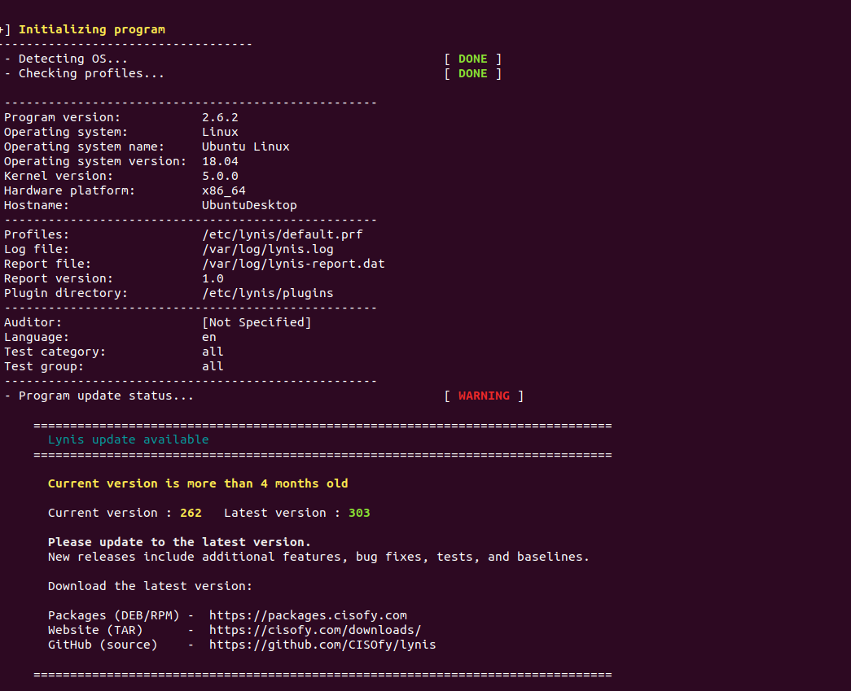

### **Bonus**

1. Command to install chkrootkit:  
   $sudo apt install chkrootkit
2. Command to see documentation and instructions:  
   $sudo chkrootkit -h
3. Command to run expert mode:  
   $sudo chkrootkit -x
4. Provide a report from the chrootkit output on what can be done to harden the system.  
   $sudo chkrootkit -h or $sudo chkrootkit -x
   * Screenshot of end of sample output:

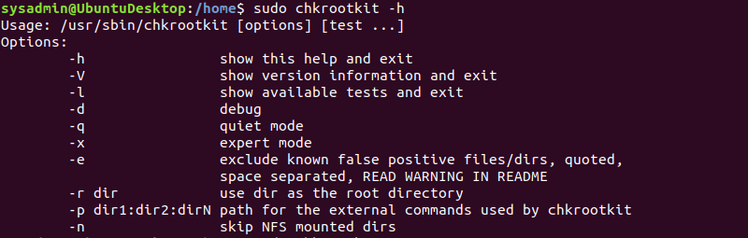

$sudo chkrootkit -x